Automatic Greenhouse Construction with Arduino

**Materials:**

* [Arduino UNO R3 Klon](https://www.robotistan.com/arduino-uno-r3-klon-usb-kablo-hediyeli-usb-chip-ch340?h=424a5daa&OM.zn=CategoryPage%20-%20CatTopSeller-w21&OM.zpc=13956)
* [2×16 LCD Ekran](https://www.robotistan.com/2x16-lcd-ekran-mavi-uzerine-beyaz)
* [Mini Dalgıç Pompa 6V](https://www.robotistan.com/mini-dalgic-pompa-6v-120-litresaat)
* [2 Kanal 5 V Röle Kartı](https://www.robotistan.com/2-way-5v-relay-module-2li-5v-role-karti-1)
* [Su Seviyesi / Yağmur Sensörü](https://www.robotistan.com/su-seviyesi-yagmur-sensoru-water-level-rain-sensor)
* [DHT11 Sıcaklık ve Nem Sensörü](https://www.robotistan.com/dht11-sicaklik-ve-nem-sensoru)
* [Toprak Nemi Algılama Sensörü](https://www.robotistan.com/toprak-nemi-algilama-sensoru)
* [80x80x25 mm Fan](https://www.robotistan.com/80x80x25mm-fan-12v-0)
* [IRFZ44 – 49 A 55 V MOSFET](https://www.robotistan.com/irfz44n-49a-55v-mosfet-to220)
* [IC205 180 Derece Sürgülü Siviç](https://www.robotistan.com/ic205-180-derece-surgulu-switch)
* [IC177 Mavi Push Buton](https://www.robotistan.com/ic177-mavi-push-buton)
* [10 mm LDR](https://www.robotistan.com/10mm-ldr-1)
* [10K Direnç](https://www.robotistan.com/14w-10k-direnc-paketi-10-adet?#ins_eureka=eyJjYW1wYWlnbklkIjowLCJrZXl3b3JkIjoiMTBrIiwib3JkZXIiOjEsInByb2R1Y3RJZCI6IjEyMjI3Iiwic2VhcmNoSWQiOiIxNjE1NjU1NzQ3SW9UVDdkSklsNiJ9)
* [10k pot](https://www.robotistan.com/10k-potansiyometre-ayarli-direnc?#ins_eureka=eyJjYW1wYWlnbklkIjowLCJrZXl3b3JkIjoiMTBrIHBvdCIsIm9yZGVyIjo0LCJwcm9kdWN0SWQiOiIxMjQ0NSIsInNlYXJjaElkIjoiMTYxNTY1NzYwOG1iSU5IU1JpVWoifQ%3D%3D)

**Circuit :**

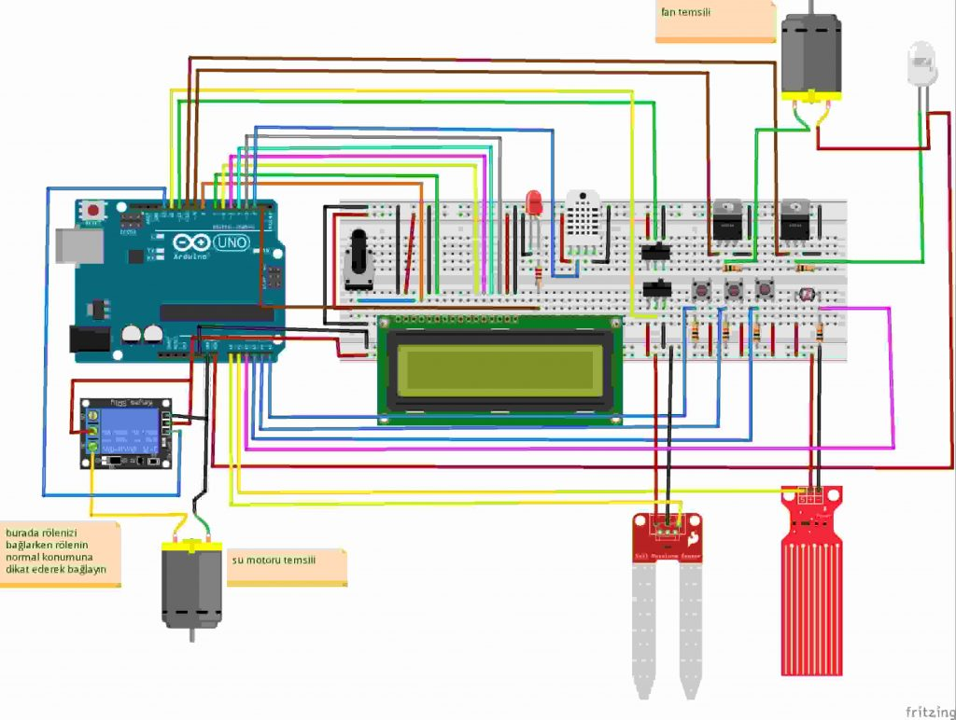

**Codes:**

|  |
| --- |
| #include <LiquidCrystal.h>  #include <DHT.h>  LiquidCrystal lcd(8, 7, 6, 5, 4, 3);  #define DHTPIN 2  #define DHTTYPE DHT11  DHT dht(DHTPIN, DHTTYPE);  int esik1= 600;  int esik2= 300;  int esik3= 800;  int buttonfan= A4;  int buttonfanDurum=0;  int buttonled= A3;  int buttonledDurum=0;  int buttonnem= A5;  int buttonnemDurum=0;  int switch1= 11;  int switch1Durum= 0;  int switch2= 12;  int switch2Durum= 0;  int ldr= A2;  int ldrDurum;  int suseviye= A1;  int suveri;  int topraknem= A0;  int toprakveri;  int fan= 9;  int led= 10;  int sumotoru= 13;  int fanhiz=0;  int ledparlaklik=0;  void setup() {  dht.begin();  lcd.begin(16, 2);  pinMode(buttonfan, INPUT);  pinMode(buttonled, INPUT);  pinMode(buttonnem, INPUT);  pinMode(switch1, INPUT);  pinMode(switch2, INPUT);  pinMode(ldr, INPUT);  pinMode(suseviye, INPUT);  pinMode(topraknem, INPUT);  pinMode(fan, OUTPUT);  pinMode(led, OUTPUT);  pinMode(sumotoru, OUTPUT);  pinMode(1, OUTPUT);  }  void loop() {  int temp = dht.readTemperature();  int hum = dht.readHumidity();    buttonledDurum=digitalRead(buttonled);  buttonfanDurum=digitalRead(buttonfan);  buttonnemDurum=digitalRead(buttonnem);  switch1Durum=digitalRead(switch1);  switch2Durum=digitalRead(switch2);  ldrDurum=analogRead(ldr);  suveri=analogRead(suseviye);  toprakveri=analogRead(topraknem);  //**** Water tank ****//  if(suveri>600){  digitalWrite(1, HIGH);    }  if(suveri<300){  digitalWrite(1, LOW);  }  //******** user mode ********//  if(switch1Durum == LOW && switch2Durum==LOW){  lcd.clear();  lcd.setCursor(0,0);  lcd.print("temp:");  lcd.print(temp);  lcd.print("c");  lcd.setCursor(9, 0);  lcd.print("Hum:%");  lcd.print(hum);  lcd.setCursor(0, 1);  lcd.print("L:");  lcd.print(ledparlaklik);  lcd.setCursor(5,1);  lcd.print("F:");  lcd.print(fanhiz);  lcd.setCursor(10, 1);  lcd.print("T:");  lcd.print(esik1);  delay(100);  //******** fan speed ********//  if(buttonfanDurum == HIGH){  fanhiz= fanhiz +10;  }  if(fanhiz==260){  fanhiz=0;  }  analogWrite(fan, fanhiz);  //********led parlaklik********//  if(buttonledDurum == HIGH){  ledparlaklik= ledparlaklik +10;  }  if(ledparlaklik==260){  ledparlaklik=0;  }  if(ldrDurum> 900){  analogWrite(led, ledparlaklik);  }  else{  analogWrite(led, LOW);  }  //******** water ********//  if(buttonnemDurum==HIGH){  delay(10);  esik1= esik1+ 100;  }  if (esik1== 1100){  esik1=600;  }  if(toprakveri> esik1){  digitalWrite(sumotoru, HIGH);  delay(5000);  digitalWrite(sumotoru, LOW);  delay(5000);    }  if(toprakveri<esik1){  digitalWrite(sumotoru, LOW);  }  }  //******** rainforest ********//  if(switch1Durum == HIGH && switch2Durum == LOW){  lcd.clear();  lcd.setCursor(0,0);  lcd.print("Yagmur ormani");  lcd.setCursor(0,1);  lcd.print("temp:");  lcd.print(temp);  lcd.print("C");  lcd.setCursor(9, 1);  lcd.print("Hum:%");  lcd.print(hum);  delay(100);  analogWrite(fan, 200);  if (ldrDurum> 900){  analogWrite( led, 50);  }  else{  analogWrite(led, LOW);    }  //******** water ********//  if(toprakveri> esik2){  digitalWrite(sumotoru, HIGH);  delay(5000);  digitalWrite(sumotoru, LOW);  delay(500);  }  if(toprakveri<esik2){  digitalWrite(sumotoru, LOW);  }  }  //******** temperature ********//  if(switch1Durum == HIGH && switch2Durum == HIGH){  lcd.clear();  lcd.setCursor(5,0);  lcd.print("Col");  lcd.setCursor(0,1);  lcd.print("temp:");  lcd.print(temp);  lcd.print("C");  lcd.setCursor(9, 1);  lcd.print("Hum:%");  lcd.print(hum);  delay(100);  analogWrite(fan, 0);  if (ldrDurum> 900){  analogWrite( led, 250);  }  else{  analogWrite(led, LOW);    }  //******** water ********//  if(toprakveri> esik3){  digitalWrite(sumotoru, HIGH);  delay(5000);  digitalWrite(sumotoru, LOW);  delay(500);  }  if(toprakveri<esik3){  digitalWrite(sumotoru, LOW);  }    }  } |

Source: https://maker.robotistan.com/arduino-ile-otomatik-sera/