Arduino Laser Infrared Thermometer

**Materials:**

* Momentary Button Switch
* Resistors (5K Ohm, 200 Ohm)
* 5V Laser
* Arduino Nano
* On/Off Switch
* OLED 0.96" Screen
* GY-906 Temperature Sensor (or MLX90614 Sensor with proper capacitors/resistors)
* 9V Battery

**Circuit :**

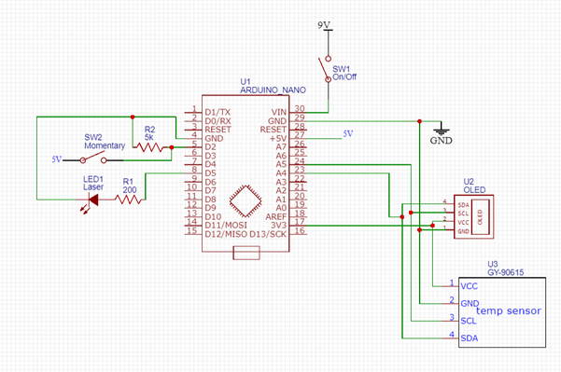

**Codes:**

|  |
| --- |
| //MN Maker  //Laser Temp Gun  //10.6.19  #include <Wire.h>  #include <Adafruit_MLX90614.h>  #include <Adafruit_SSD1306.h>  #define SCREEN_WIDTH 128 // OLED display width, in pixels  #define SCREEN_HEIGHT 64 // OLED display height, in pixels  const int Laser_Pin=5; //Laser Pin  int buttonState = 0;  const int buttonPin = 2; // the number of the pushbutton pin  // Declaration for an SSD1306 display connected to I2C (SDA, SCL pins)  Adafruit_SSD1306 display(SCREEN_WIDTH, SCREEN_HEIGHT, &Wire, -1);  Adafruit_MLX90614 mlx = Adafruit_MLX90614();  void setup() {  Serial.begin(9600);  Serial.println("Adafruit MLX90614 test");    pinMode(Laser_Pin,OUTPUT);  pinMode(buttonPin, INPUT);    if(!display.begin(SSD1306_SWITCHCAPVCC, 0x3C)) { // Address 0x3D for 128x64  Serial.println(F("SSD1306 allocation failed"));  for(;;);  }  display.clearDisplay();  display.setRotation(2);  display.setTextSize(1);  display.setTextColor(WHITE);  display.setCursor(0, 35);  display.println("Initializing Temp");  display.display();  delay(250);  display.clearDisplay();  mlx.begin();    }  void loop() {  buttonState = digitalRead(buttonPin);  Serial.println(buttonState);    Serial.print("Ambient = "); Serial.print(mlx.readAmbientTempC());  Serial.print("*C\tObject = "); Serial.print(mlx.readObjectTempC()); Serial.println("*C");  Serial.print("Ambient = "); Serial.print(mlx.readAmbientTempF());  Serial.print("*F\tObject = "); Serial.print(mlx.readObjectTempF()); Serial.println("*F");    // check if the pushbutton is pressed. If it is, the buttonState is HIGH:  if (buttonState == HIGH) {  // turn LED on:  digitalWrite(Laser_Pin, HIGH);    display.clearDisplay();  display.setTextSize(2); //Size 2 means each pixel is 12 width and 16 high  display.setCursor(25, 10);  display.print(mlx.readObjectTempC());  display.setCursor(95, 10);  display.print("C");  display.setTextSize(2);  display.setCursor(25, 36);  display.print(mlx.readObjectTempF());  display.setCursor(95, 36);  display.print("F");  display.display();    } else {  // turn LED off:  digitalWrite(Laser_Pin, LOW);    display.clearDisplay();  display.setTextSize(2); //Size 2 means each pixel is 12 width and 16 high  display.setCursor(35, 10);  display.print("-----");  display.setCursor(105, 10);  display.print("");  display.setTextSize(2);  display.setCursor(35, 36);  display.print("-----");  display.setCursor(105, 36);  display.print("");  display.display();  }  Serial.println();  delay(500);  } |